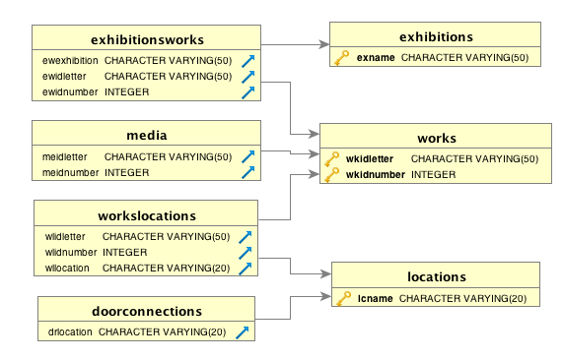Below is a entity-relationship diagram for Assignment1.

Table **Exhibitions**

* Meaning of the name

I choose this name because this table contains all the current exhibitions in the museum.

* Attributes (used prefix of ex, which stands for exhibition)
  + exName: name of the exhibition
  + exDescription: description of the exhibition
  + exStartDate: start date of the exhibition
  + exEndDate: end date of the exhibition
  + exLocation: exhibition location
* Associated Views
  + ExhibitionsView: a view for exhibitions table
  + ExhibitionsList: a list of all exhibitions (including name, description, location, and number of works)

Table **Works**

* Meaning of the name

I choose this name because this table contains all the works in the museum.

* Attributes (used prefix of wk, which stands for works)
  + wkIDLetter: identifier of letters for this work
  + wkIDNumber: identifier of numbers for this work
  + wkName: work name
  + wkType: work type
  + wkSubType: work sub type
  + wkAuthor: work author
  + wkCompletionDate: date of completion of this work
  + wkAcquisitionDate: date of acquisition of this work
  + wkInsuranceValue: insurance value of this work
  + wkDescription: work description
* Associated Views:
  + WorksView: a view for works table
  + WorksInStorage: a list of work a listing of all works (including their identifier, name, and insurance value) that are currently in storage
  + AvailableWorks: a listing of works sorted by when they are available for use in a new exhibition and by classification and by name of the work

Table **Media**

* Meaning of the name

I choose this name because this table contains all the media associated with different works.

* Attributes (used prefix of me, which stands for media)
  + meIDLetter: identifier of letters for the work that this medium belongs to
  + meIDNumber: identifier of numbers for the work that this medium belongs to
  + meMaterial: the material of this work
* Associated Views:
  + MediaView: a view for media table

Table **ExhibitionWorks**

* Meaning of the name

I choose this name because this table contains the works from three different exhibitions.

* Attributes (used prefix of ew, which stands for Exhibition Works)
  + ewExhibition: name for the exhibition that the work is displayed at
  + ewIDLetter: identifier of letters for the associated work displayed at this exhibition
  + ewIDNumber: identifier of numbers for the associated work displayed at this exhibition
* Associated Views:
  + ExhibitionWorksView: a view for exhibition works table
  + PublicWorks: a listing of all publicly available data on all works in each of the exhibitions sorted by exhibition and by the name of the work

Table **Locations**

* Meaning of the name

I choose this name because this table contains five locations in the museum.

* Attributes( used prefix of lc, which stands for location)
  + lcName: location name
  + lcDimension: location dimensions
  + lcMinNumWork: the minimum number of works in this location
  + lcMaxNumWork: the maximum number of works in this location
* Associated Views:
  + LocationsView: a view for locations table

Table **WorksLocations**

* Meaning of the name

I choose this name because this table contains the locations for each work.

* Attributes (used prefix of wl, which stands for works locations)
  + wlIDLetter: the identifier of letters for the works in this location
  + wlIDNumber: the identifier of numbers for the works in this location
  + wlLocation: locationis for the works
* Associated Views:
  + WorksLocationsView: a view for works locations table

Table **DoorConnections**

* Meaning of the name

I choose this name because this table contains doors connecting to different locations.

* Attributes (used prefix of dr, which stands for door connections)
  + drLoation: door location
  + drConnectedLocation: the locations that this door connected
* Associated Views:
  + DoorConnectionsView: a view for door connections table